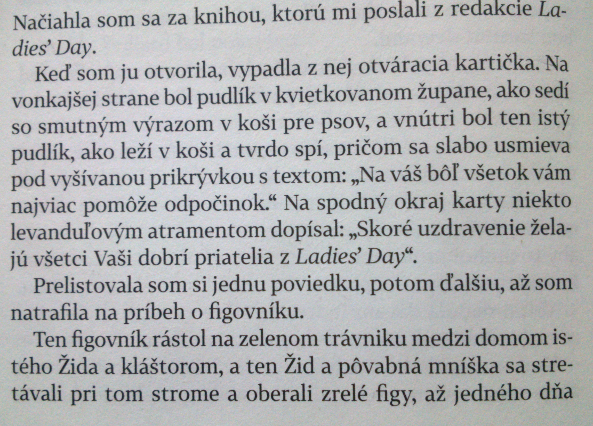
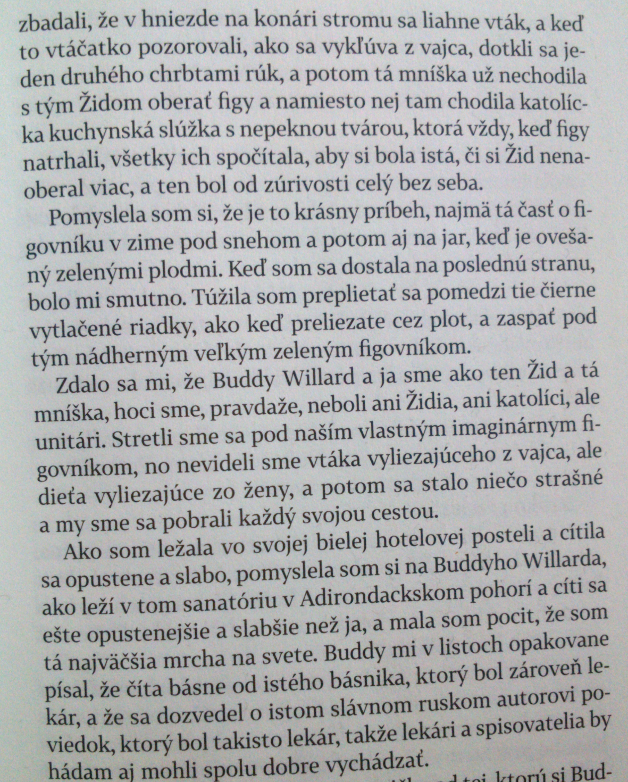

I reached for the book the people from Ladies' Day had sent.
When I opened it a card fell out. The front of the card showed a poodle in a
flowered bedjacket sitting in a poodle basket with a sad face, and the inside of the card
showed the poodle lying down in the basket with a smile, sound asleep under an
embroidered sampler that said, "You'll get well best with lots and lots of rest." At the
bottom of the card somebody had written, "Get well quick! from all of your good friends
at Ladies' Day," in lavender ink.
I flipped through one story after another until finally I came to a story about a fig
tree.
This fig grew on a green lawn between the house of a Jewish man and a convent,
and the Jewish man and a beautiful dark nun kept meeting at the tree to pick the ripe figs,
until one day they saw an egg hatching in a bird's nest on a branch of the tree, and as they
watched the little bird peck its way out of the egg, they touched the backs of their hands
together, and then the nun didn't come out to pick figs with the Jewish man any more but
a mean-faced Catholic kitchen maid came to pick them instead and counted up the figs
the man picked after they were both through to be sure he hadn't picked any more than
she had, and the man was furious.
I thought it was a lovely story, especially the part about the fig tree in winter
under the snow and then the fig tree in spring with all the green fruit. I felt sorry when I came to the last page. I wanted to crawl in between those black lines of print the way you
crawl through a fence, and go to sleep under that beautiful big green fig tree.
It seemed to me Buddy Willard and I were like that Jewish man and that nun,
although of course we weren't Jewish or Catholic but Unitarian. We had met together
under our own imaginary fig tree, and what we had seen wasn't a bird coming out of an
egg but a baby coming out of a woman, and then something awful happened and we went
our separate ways.
As I lay there in my white hotel bed feeling lonely and weak, I thought I was up
in that sanatorium in the Adirondacks, and I felt like a heel of the worst sort. In his letters
Buddy kept telling me how he was reading poems by a poet who was also a doctor and
how he'd found out about some famous dead Russian short-story writer who had been a
doctor too, so maybe doctors and writers could get along fine after all.
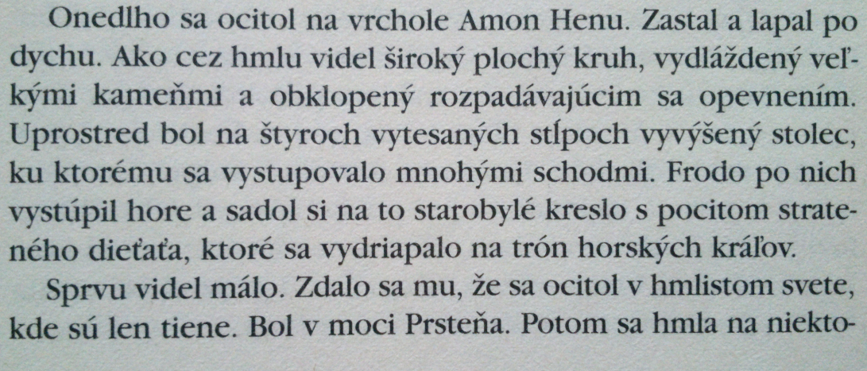
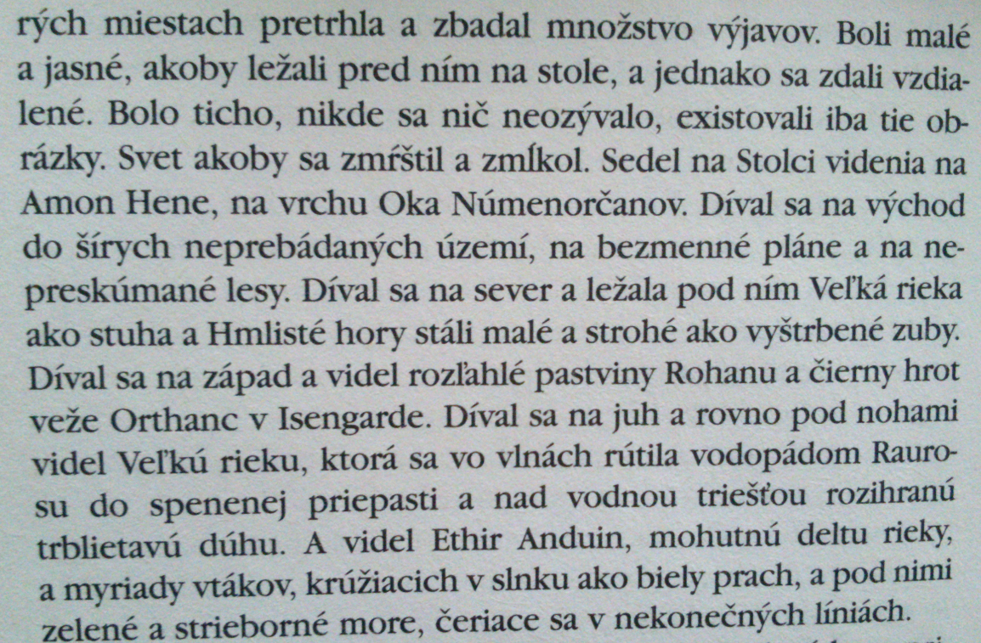

Soon he came out alone on the summit of Amon Hen, and halted, gasping for breath. He saw as through a mist a wide flat
circle, paved with mighty flags, and surrounded with a
crumbling battlement; and in the middle, set upon four carven
pillars, was a high seat, reached by a stair of many steps. Up he
went and sat upon the ancient chair, feeling like a lost child
that had clambered upon the throne of mountain-kings.
At first he could see little. He seemed to be in a world of mist
in which there were only shadows: the Ring was upon him. Then
here and there the mist gave way and he saw many visions:
small and clear as if they were under his eyes upon a table,
and yet remote. There was no sound, only bright living images.
The world seemed to have shrunk and fallen silent. He was
sitting upon the Seat of Seeing, on Amon Hen, the Hill of the
Eye of the Men of Númenor. Eastward he looked into wide
uncharted lands, nameless plains, and forests unexplored.
Northward he looked, and the Great River lay like a ribbon
beneath him, and the Misty Mountains stood small and hard as
broken teeth. Westward he looked and saw the broad pastures
of Rohan; and Orthanc, the pinnacle of Isengard, like a black
spike. Southward he looked, and below his very feet the Great
River curled like a toppling wave and plunged over the falls of
Rauros into a foaming pit; a glimmering rainbow played upon
the fume. And Ethir Anduin he saw, the mighty delta of the
River, and myriads of sea-birds whirling like a white dust in the
sun, and beneath them a green and silver sea, rippling in
endless lines.

Úradný vestník Európskej únie, stiahnuté z http://apertium.eu/data, oj4-ss-1, 2011-09-02
PRIPOMIENKY ZAINTERESOVANÝCH STRÁN Pripomienky , ktoré zaslali zainteresované strany , sa obmedzujú na opakovanie tvrdení , ktoré Komisia predložila v rámci rozhodnutia o otvorení . Preto sa neopakujú v tomto rozhodnutí . PRIPOMIENKY FRANCÚZSKYCH ORGÁNOV Tvrdenia predložené francúzskymi orgánmi sa sústredili na základný problém , a to , či osobitný daňový systém ustanovený štátom v prospech FT nezvýhodňuje tento podnik . Francúzske orgány uznávajú , že FT sa riadil osobitným systémom odvodu živnostenskej dane od roku 1991 do roku 2002 , ale usúdili , že tento systém mu nepriniesol žiadne daňové zvýhodnenie a nijako nezasahuje do verejných zdrojov , pretože išlo o zvýšenie odvodu daní FT vzhľadom na podmienky stanovené všeobecnými pravidlami . Francúzske orgány viedli k tomuto záveru tri skutočnosti uvedené v nasledujúcich bodoch : od roku 1991 do roku 1993 FT odviedlo preddavok do všeobecného rozpočtu , ktorý má podľa francúzskych orgánov rovnakú hodnotu ako živnostenská daň , od ktorej bol oslobodený , a ( najmä ) zahŕňa sumu samotnej živnostenskej dane , francúzske orgány zdôrazňujú skutočnosť , že zákon č . 90 - 568 ustanovil raz a navždy jedinečný daňový systém pre FT od roku 1991 do roku 2003 .
Official Journal of the European Union, downloaded from http://apertium.eu/data, oj4-ss-1
COMMENTS FROM INTERESTED PARTIES The comments sent by interested parties merely repeat the arguments presented by the Commission in the opening decision . Consequently , they will not be reproduced in this Decision . COMMENTS FROM THE FRENCH AUTHORITIES The French authorities ' arguments focus on a fundamental point , namely that the specific scheme established by the State for FT did not confer any advantage on the company . The French authorities acknowledge that FT was subject to a special scheme in relation to business tax from 1991 to 2002 inclusive , but they consider that the scheme gave it no edge and in no way affected public resources , resulting in an overtaxation of FT compared with the ordinary - law situation . The French authorities base this conclusion on the following three points : between 1991 and 1993 inclusive , FT was subject to a levy for the benefit of the general budget which , according to the French authorities , was , was equivalent to payment of business tax and included ( inter alia ) the amount of the business tax itself ; the French authorities stress that Law No 90 - 568 established once and for all a single tax scheme applicable to FT from 1991 to 2003 .
Zviera na odstrel (z b. zb. Krá: Zo života a piesní Krá)

Krá, dokopaný na kaliku
s hlavou prestrelenou guľkou intelektu
na mieste oslepený v paľbe očí
vlastnými rebrami pribitý k zemi
s priedušnicou, ktorá ho priškrtila
ešte i v poslednom dychu
vlastným srdcom dotlčený do bezvedomia

zbadal, ako ho život prebodáva, záblesk sna
zatiaľ čo sa topil vo vlastnej krvi

sťahovaný váhou čriev
vydal srdcervúci výkrik, čo boli v podstate jeho korene odtŕhajúce sa
od prazákladného atómu
rozovrel ústa a akoby z odstupu sa tým výkrikom nechal rozpárať

potom, zmetený medzi ostatné pozemské odpadky

ešte stihol slabučko a z diaľky zachytiť: „Je to chlapec!“

Vtedy sa všetko obrátilo na čierne

(Hughes, [2006], s. 13-14)

Ted Hughes: A Kill

Flogged lame with legs
Shot through the head with balled brains
Shot blind with eyes
Nailed down by his own ribs
Strangled just short of his last gasp
By his own windpipe
Clubbed unconscious by his own heart

Seeing his life stab through him, a dream flash
As he drowned in his own blood

Dragged under by the weight of his guts

Uttering a bowel-emptying cry which was his roots tearing out
Of the bedrock atom
Gaping his mouth and letting the cry rip through him as at a distance

And smashed into the rubbish of the ground

He managed to hear, faint and far - ‘It’s a boy!’

Then everything went black.

